Design and implement a C program to route the packet in a network using distance vector algorithm.

#include<stdio.h>
struct node
{
unsigned dist[20];
unsigned from[20];
}rt[10];
int main()
{
int dmat[20][20];
int n,i,j,k,count=0;
printf("\nEnter the number of nodes: ");
scanf("%d",&n);
printf("\nEnter the cost matrix\n");
for(i=0;i<n;i++)
for(j=0;j<n;j++)
{
scanf("%d",&dmat[i][j]);
dmat[i][i]=0;
rt[i].dist[j]=dmat[i][j];
rt[i].from[j]=j;
}
do
{
count=0;
for(i=0;i<n;i++)
{
for(j=0;j<n;j++)
{
for(k=0;k<n;k++)
{
if(rt[i].dist[j]>dmat[i][k]+rt[k].dist[j])
{
rt[i].dist[j]=rt[i].dist[k]+rt[k].dist[j];
rt[i].from[j]=k;
count++;
}
}
}
}
}while(count!=0);
for(i=0;i<n;i++)
{
printf("\n\nState value for router %d is \n",i+1);
printf("\nNode \t Via \t Dist. ");
for(j=0;j<n;j++)
{
printf("\n%d \t %d \t %d ",j+1,rt[i].from[j]+1,rt[i].dist[j]);
}
}
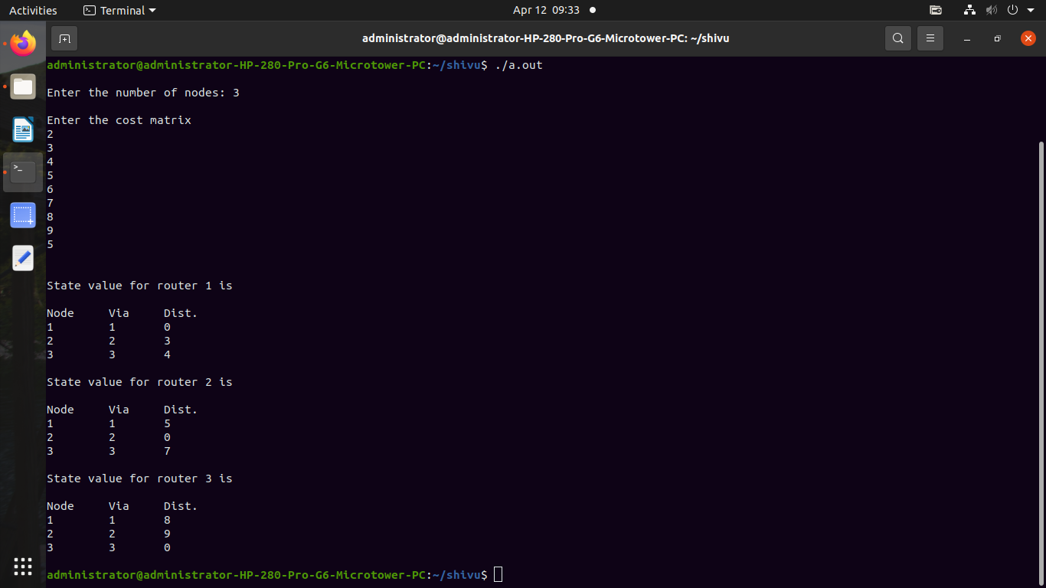
printf("\n\n");

